1xx - Controls | 2xx - Ground | 3xx - Flight | 4xx - A2A | 5xx - A2G | 6xx - Misc
504 - A/G - Rockets and APKWS

Fence In:
- Master Arm ... ARMED
- Laser ... ARM

Hydra 70 Rockets -- 70 mm rockets, M261 launcher, 7x rockets/pod -- WIP
- Select rockets with Gray Reset Hat left/right, which will show Sparse Weapon Page.
- Set up rocket options:
  - MODE OSB ...
    - SINGLES/SINGLES -- One rocket per Trigger press, alternating pods.
    - RIPPLE/SINGLES -- Fires continuously while Trigger is held, alternating pods.
    - SINGLES/PAIRS -- Two rockets per Trigger press, one from each pod simultaneously.
    - RIPPLE/PAIRS -- Fires continuously while Trigger is held, from both pods simultaneously.
  - FUZE/CUE OSB ... Not implemented in DCS?? Setting doesn't matter??
  - ZONE OSB ... Cycles ALL, A, or B zone to fire.
- Fire with Trigger 2nd Stage.

APKWS
- Set laser code on rockets in built-in kneeboard page (RShift+K). Can only be changed on the ground (weight on skids), but can be done anywhere, not just at a friendly base.
- Copilot: Set MMS laser code on MMS PAGE ... L1 OSB to cycle codes
- Set up rockets as above, SINGLES/SINGLES mode recommended.
- APKWS don't show any lock indication, they just home on the dot immediately when they see it, so in effect, you're always shooting in LOAL mode.
- APKWS seeker has about a 30 deg FOV (+/-15 deg off nose in all directions).
- Tested range from 50 ft hover: 1.5 km min to 9.5 km max.
APKWS range table -- Tested at sea level in ISA conditions from 50 ft hover
Target range | Loft angle | When to start lasing
1.5 km to 3.0 km | 5 deg (hover) | Immediately
3.0 km to 4.5 km | 5 deg (hover) | 5 sec
4.5 km to 6.0 km | 5 deg (hover) | 10 seconds
6.0 km to 8.5 km | 10 deg | 10 seconds
8.5 km to 9.5 km | 15 deg | 15 sec

MMS commands on Collective (basic commands only)
- Slew ... Ministick
- Toggle Manual/Slaved mode ... Ministick press
- Toggle Narrow/Wide FOV ... Middle Hat up/down, press repeatedly to cycle zoom within each FOV
- Point track ... Middle Hat right, press repeatedly to use Offset Point Track
- Toggle TV/TIS (IR) ... Middle Hat left

Pilot AI commands
- Toggle Pilot AI on/off ... Trim Hat press
- Toggle Pilot AI HUD display on/off ... Shift-Trim Hat press
- Pilot AI hover ... Trim Hat down
- Pilot AI turn to MMS ... Trim Hat up
- Pilot AI slide left/right in hover ... Trim Hat left/right to set speed (to stop, press Trim Hat down to hover)
- Pilot AI altitude up/down ... Shift-Trim Hat up/down
  - Pilot AI use radar alt for setting altitude (fine control in hover)... LAlt-F
  - Pilot AI use use baro alt ... LAlt-A
- Pilot AI turn left/right ... Shift-Trim Hat left/right

Rocket zones
- Rocket pods have 2 zones: A and B
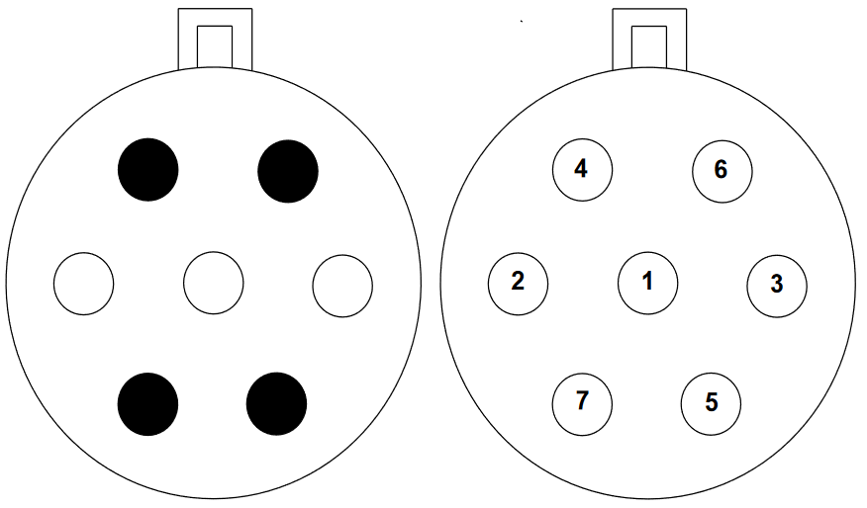(left) Zones: ● = A, ○ = B; (right) Firing Sequence
- Zone A ... 4 total: Top and bottom rockets.
- Zone B ... 3 total: Middle rockets.
- Different rockets can be loaded in each zone, and zones can be selected with ZONE OSB.

